Steps to install Falcon:

1. Pre-requisite:

Install jar file on Ambari-server.

**wget -O je-5.0.73.jar http://search.maven.org/remotecontent?filepath=com/sleepycat/je/5.0.73/je-5.0.73.jar**

**cp je-5.0.73.jar /usr/share/**

**chmod 644 /usr/share/je-5.0.73.jar**

**ambari-server setup --jdbc-db=bdb --jdbc-driver=/usr/share/je-5.0.73.jar**

**ambari-server restart**

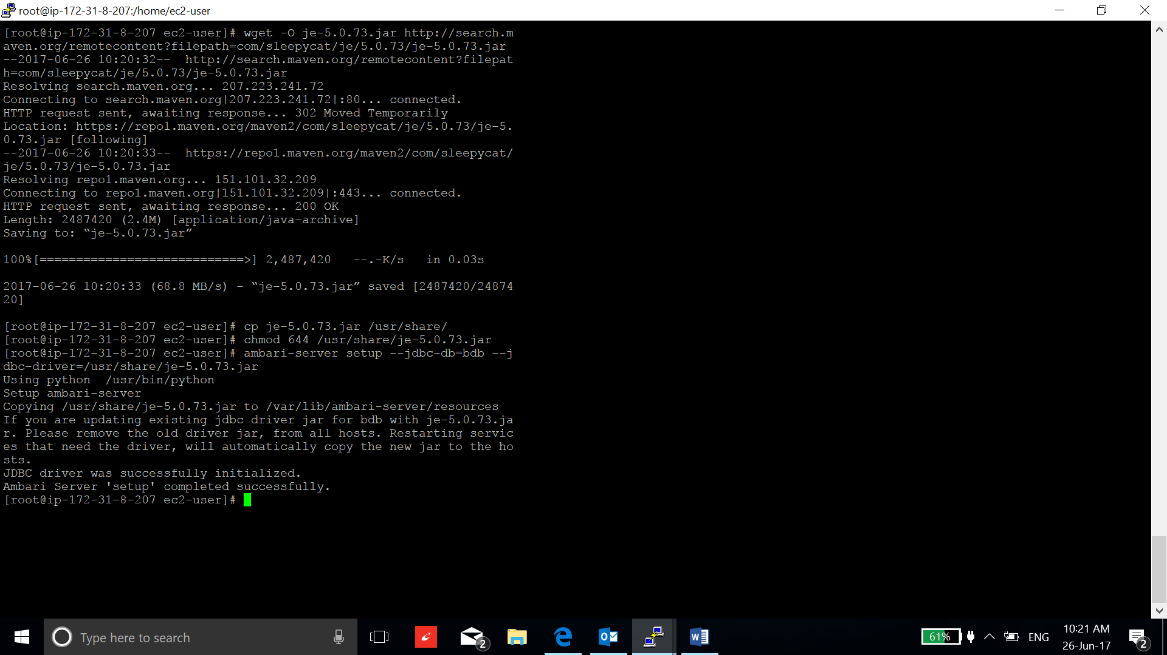

1. Go to action and select add service:

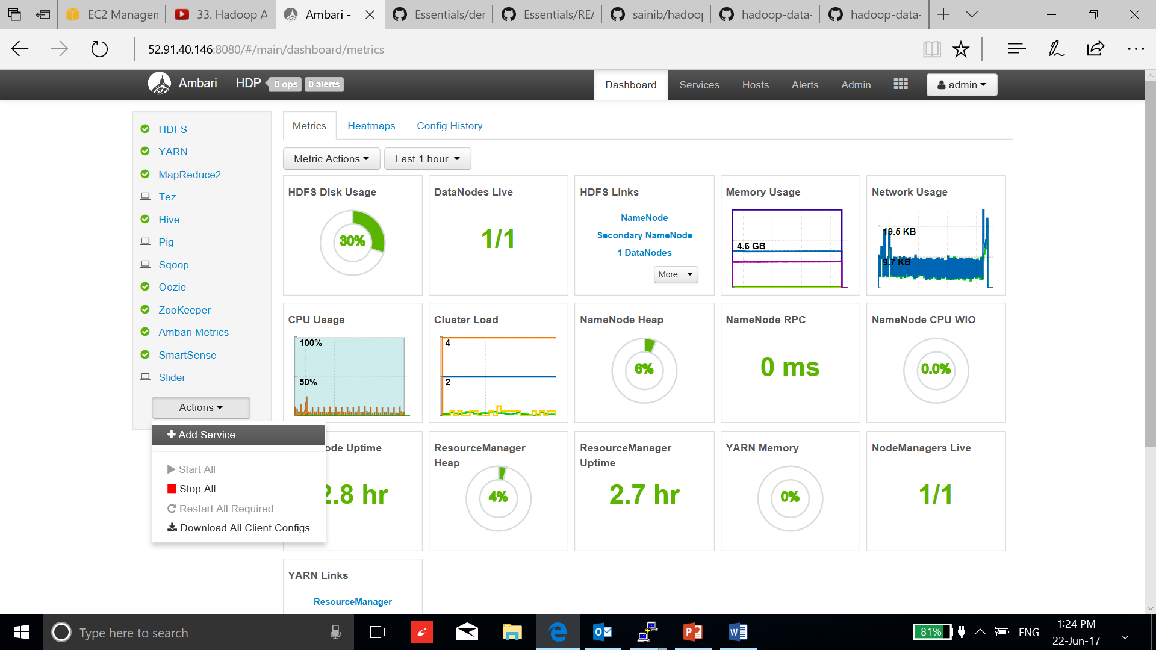

1. Tick Falcon service and select next:

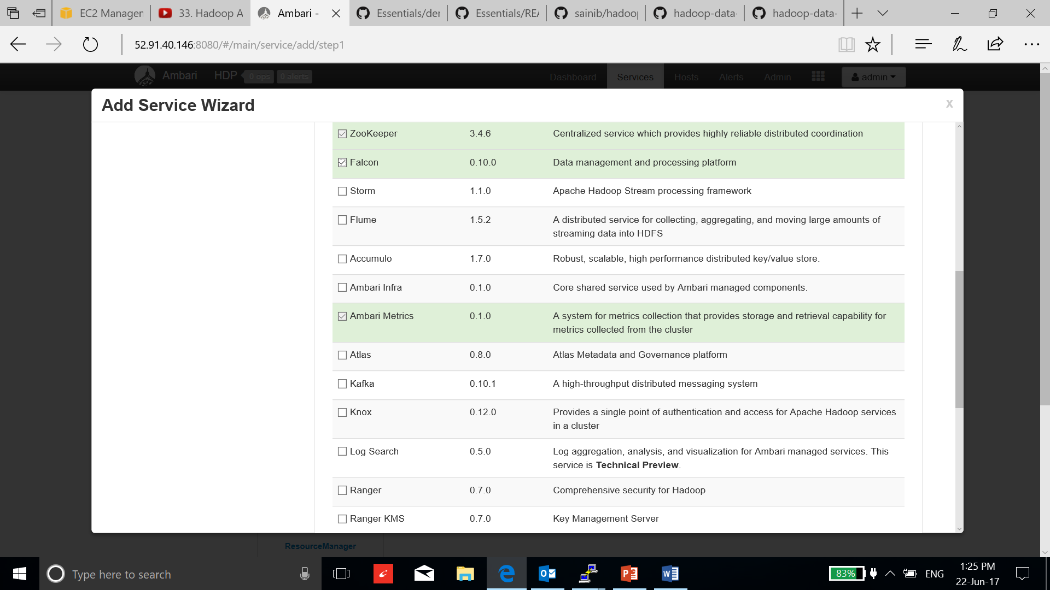

1. Select the cluster with oozie and select next:

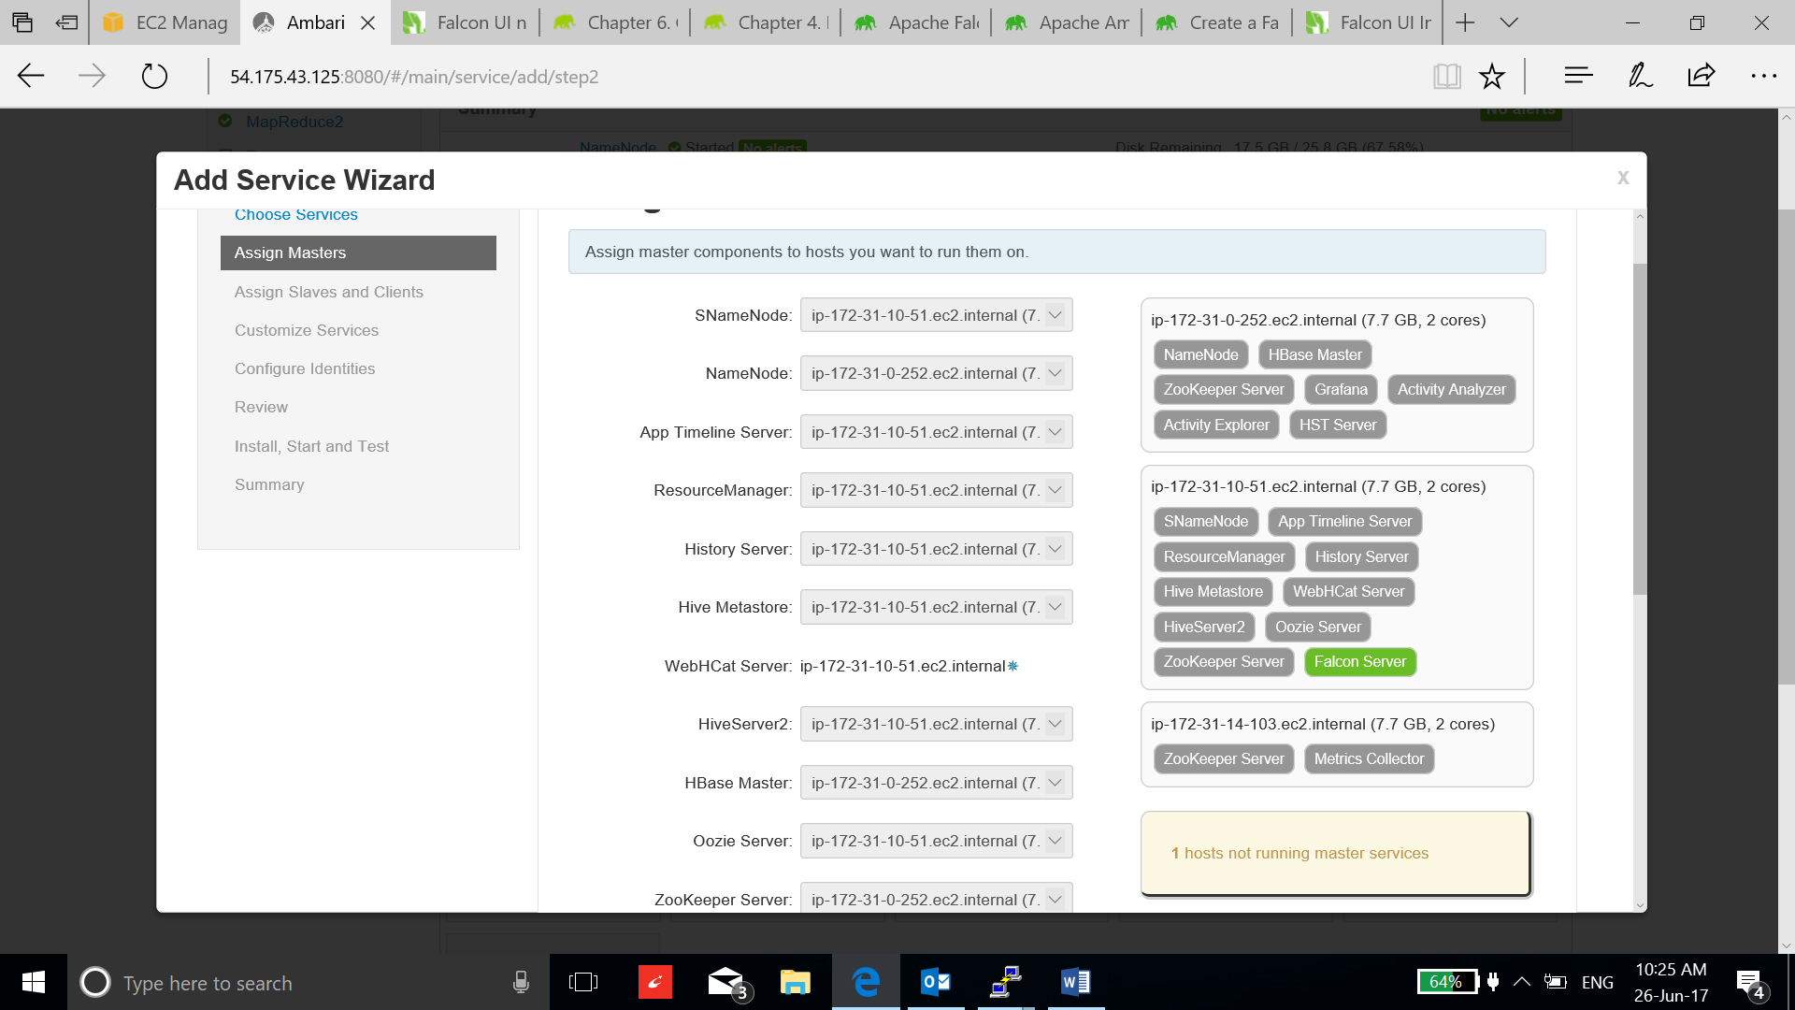

1. Select the instances to be client:

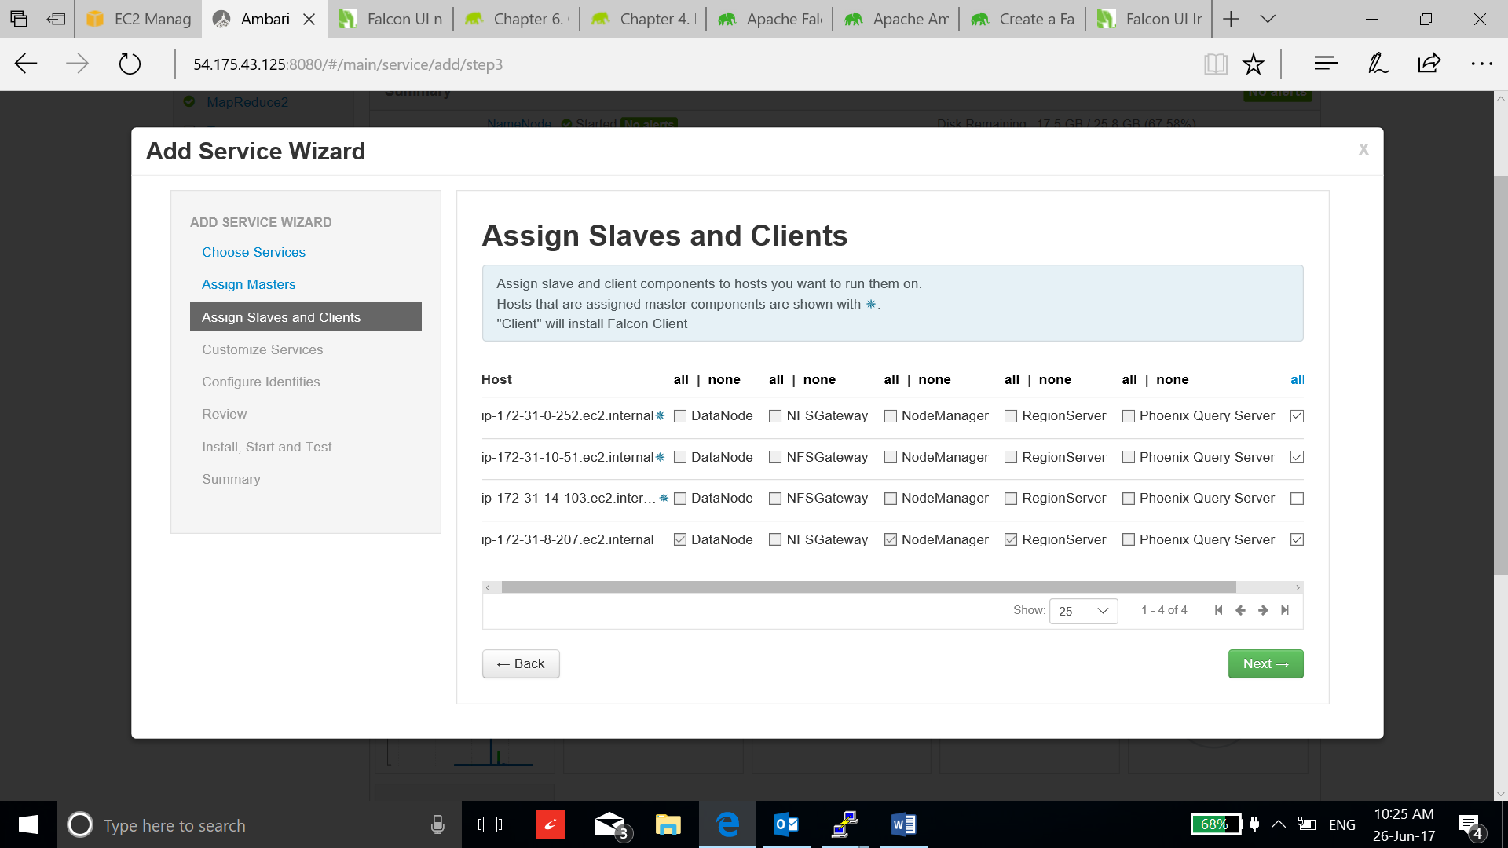

1. Leave the configuration as default and select next.

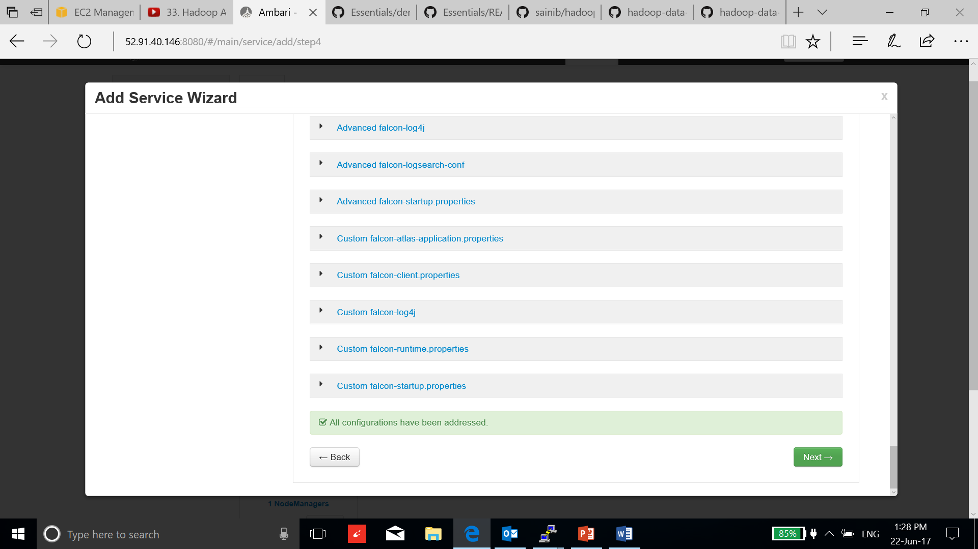

1. Accept the recommended configuration and select Ok.

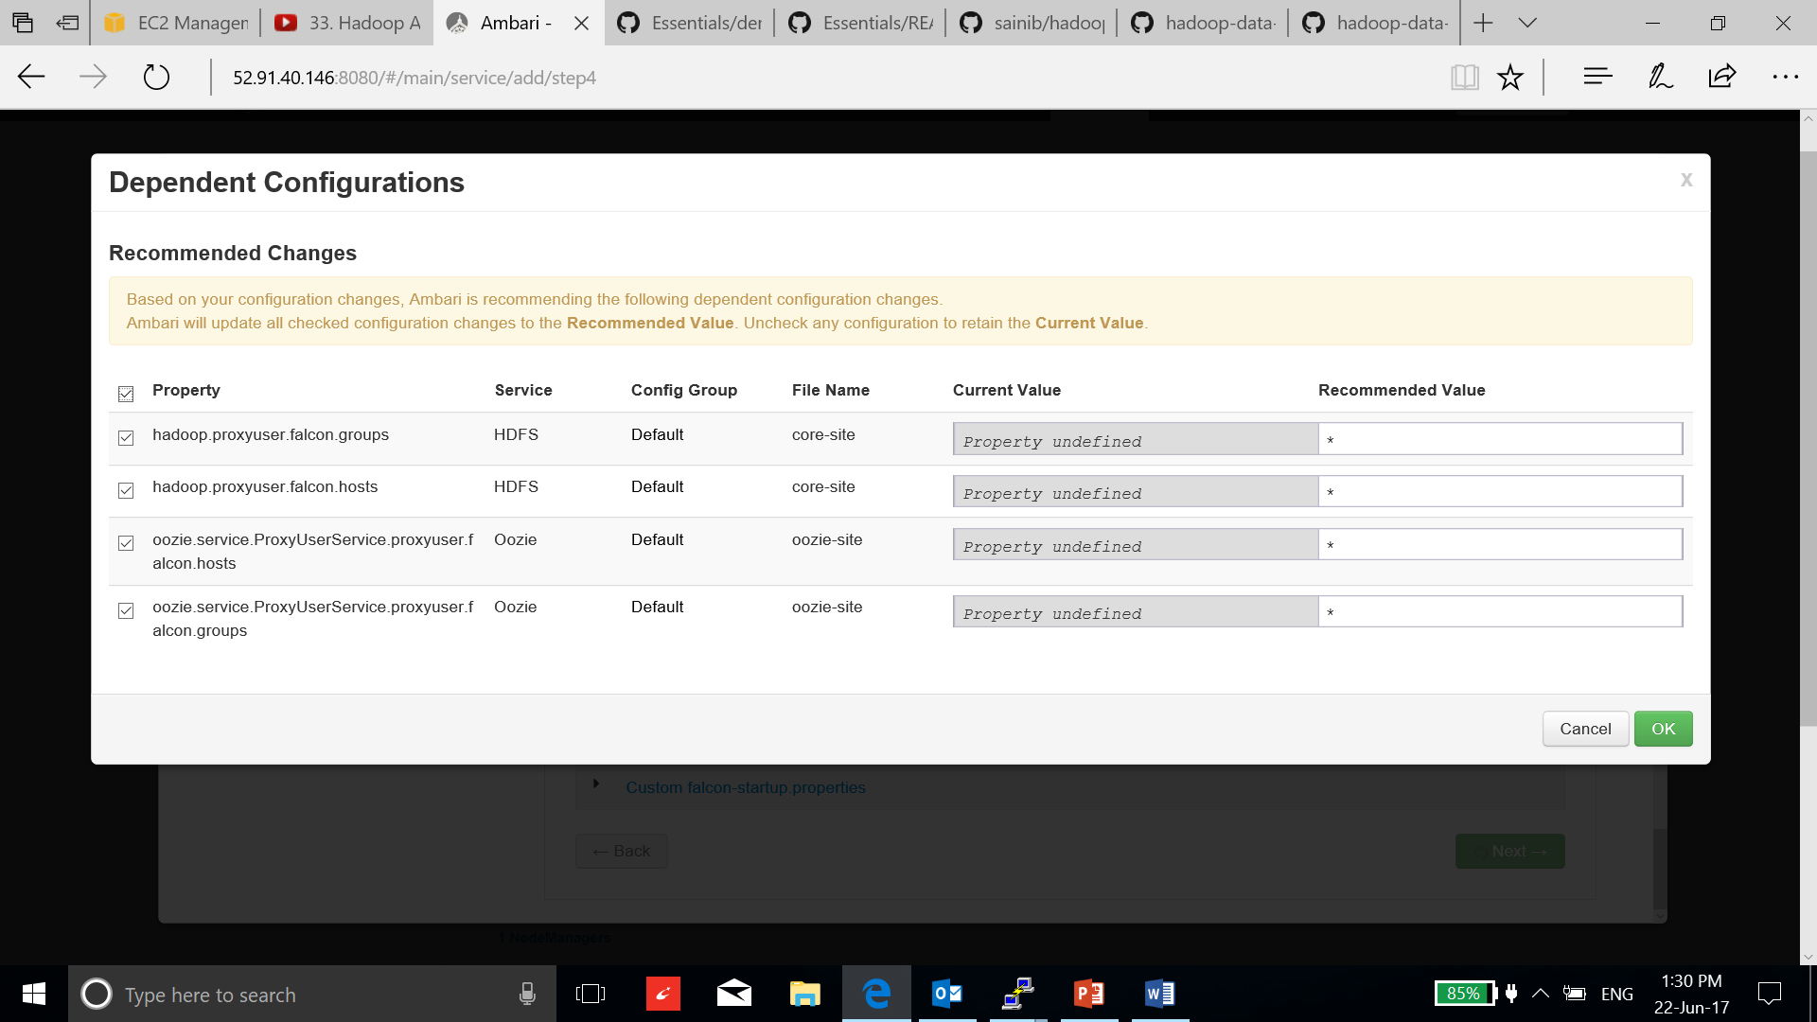

1. Review and deploy.

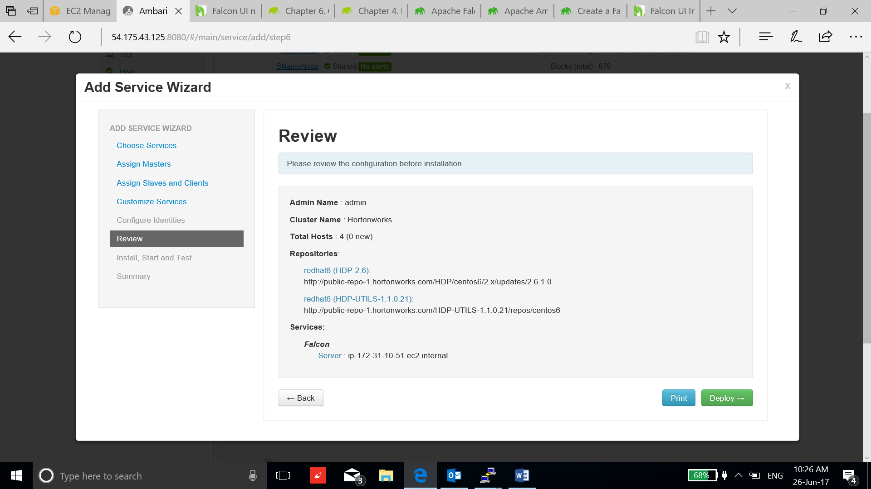

1. After the installation, click complete.

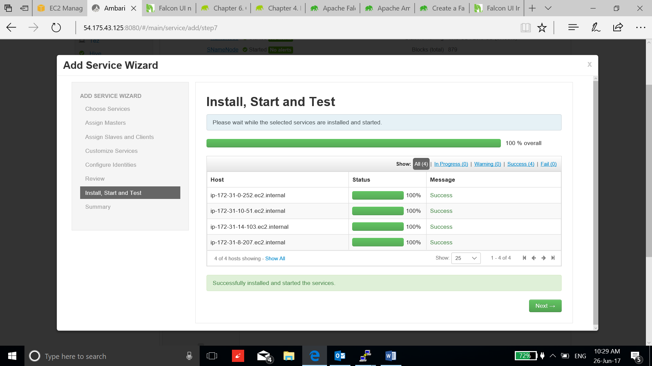

1. To validate the falcon installation, use Falcon to mirror directories from a source to a target cluster.

* Create Falcon user, go to manager ambari:

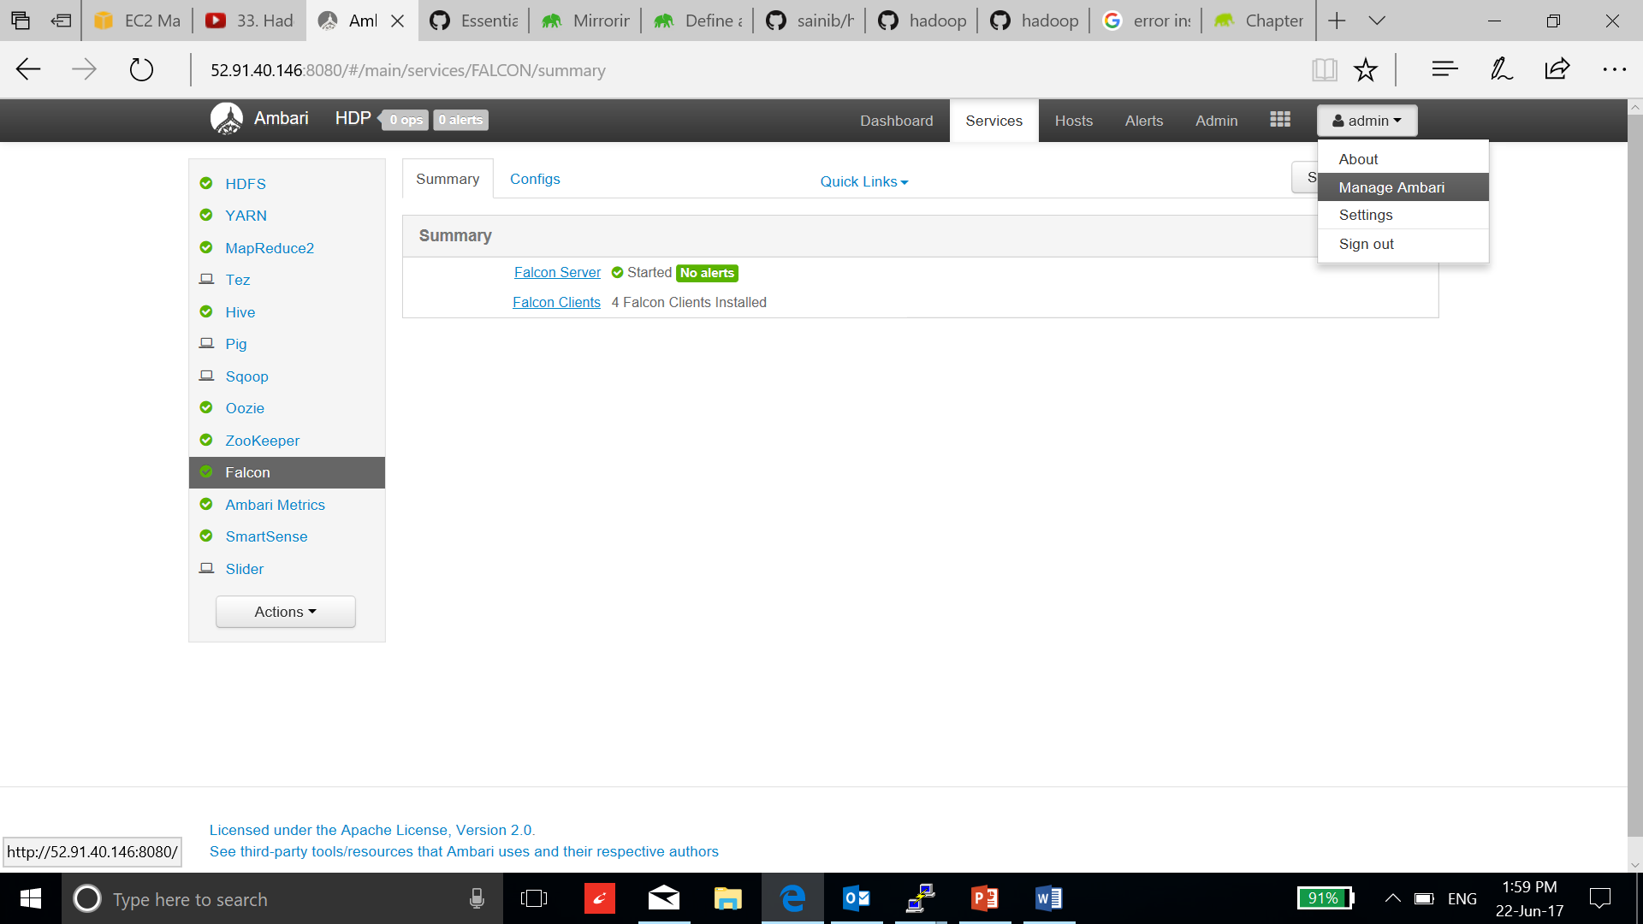

* Go to users:

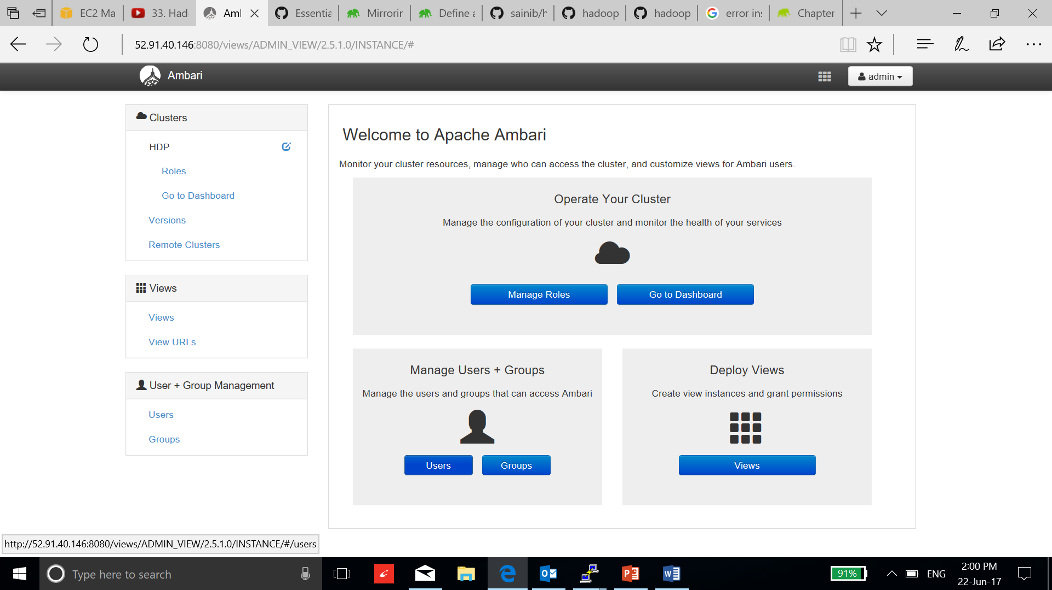

* Select create user tab:

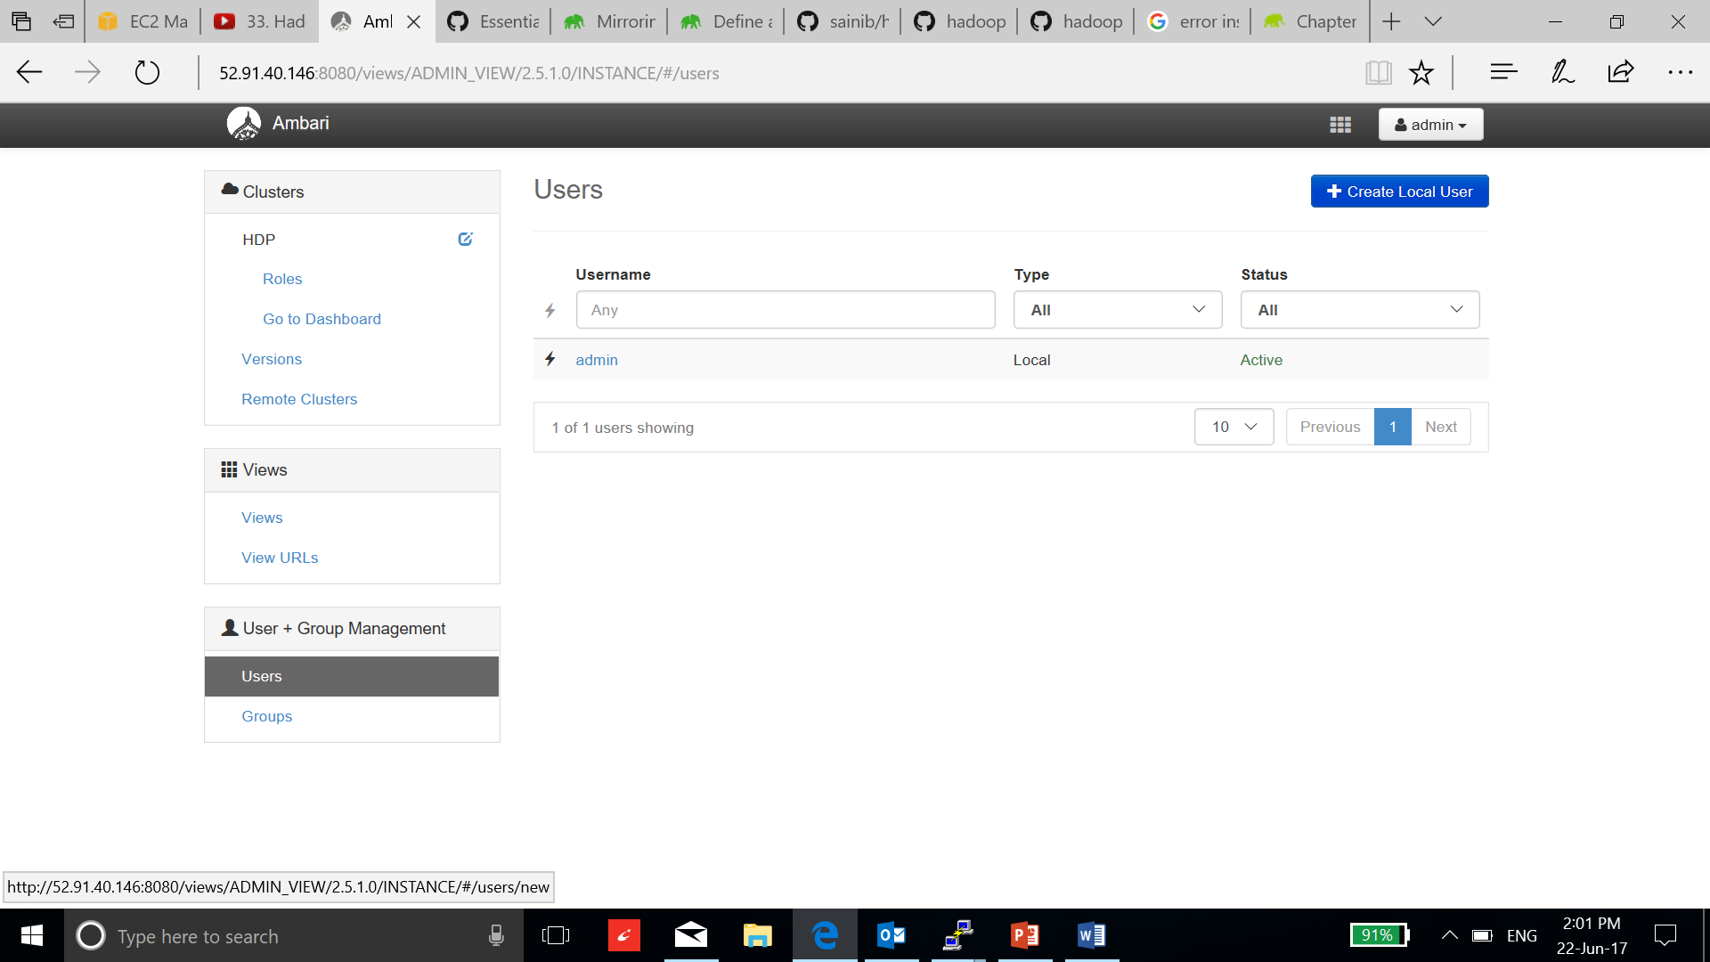

* Fill up the details:

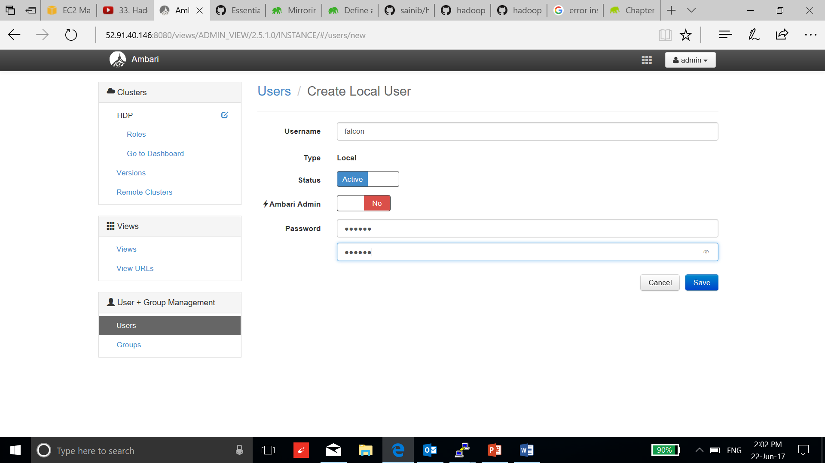

* Select save:

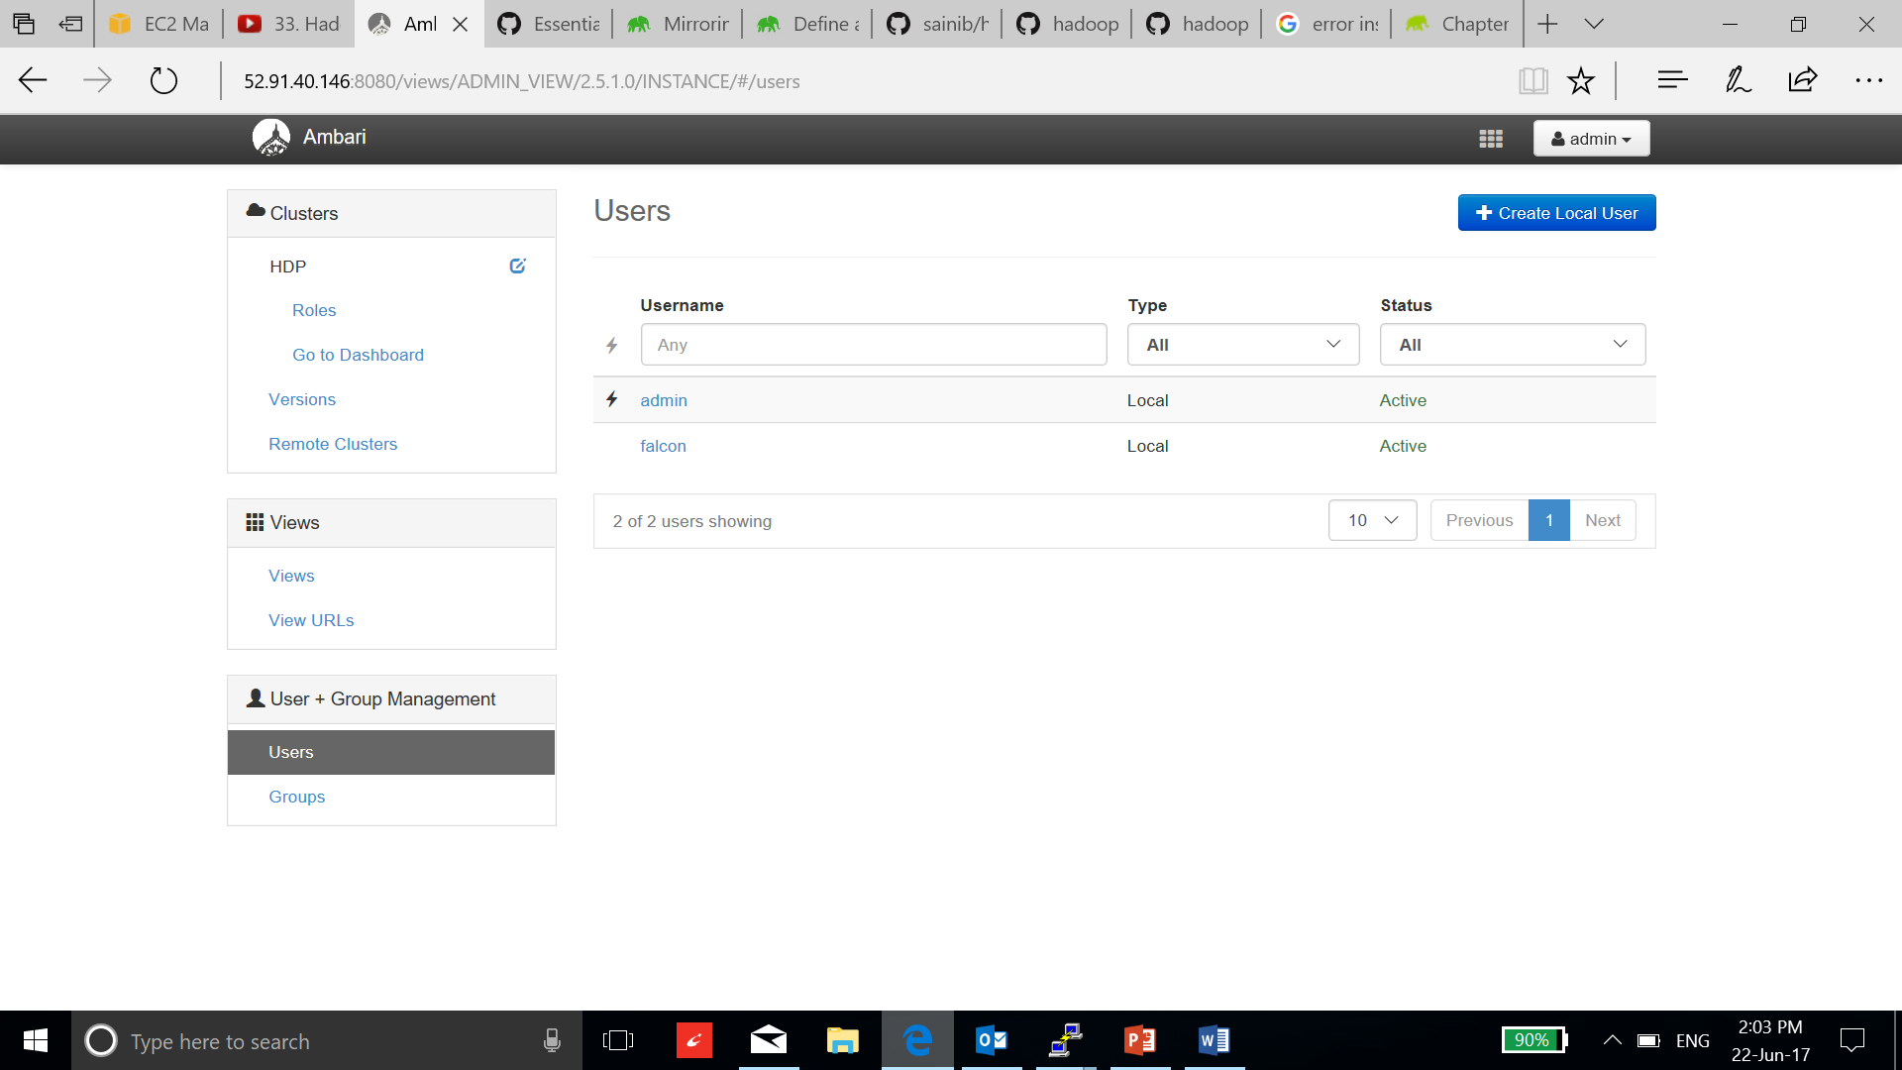

* Go to group and select create local group tab. Enter group name as Views and click save.

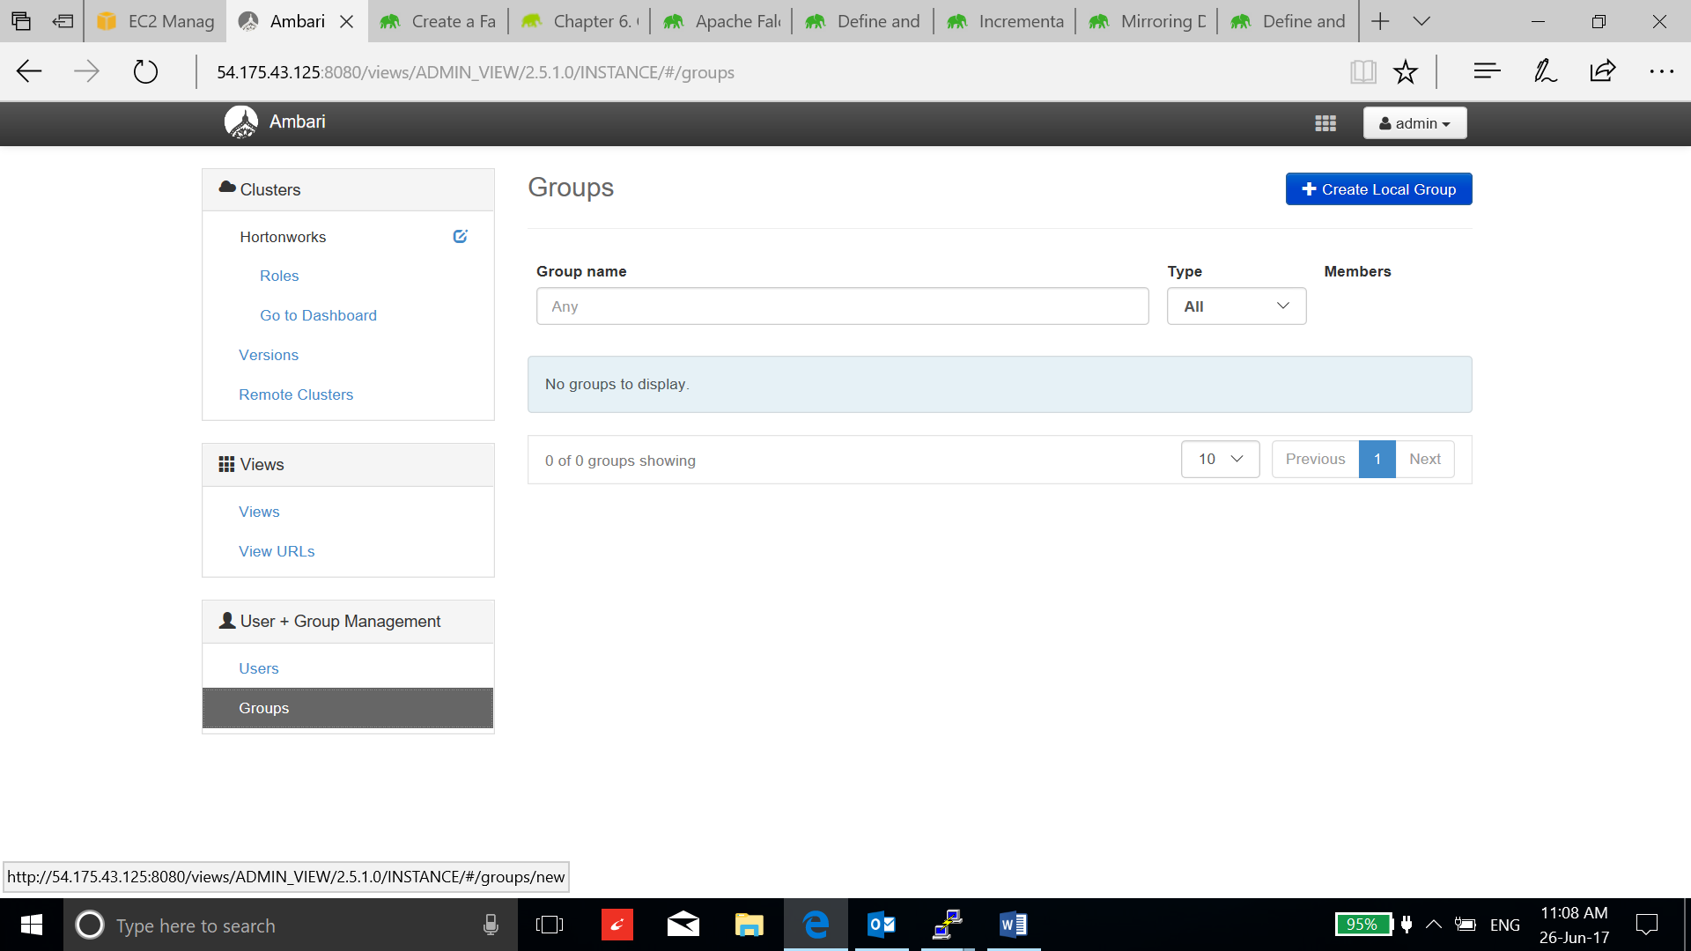

* Go to views group and add falcon as a user.

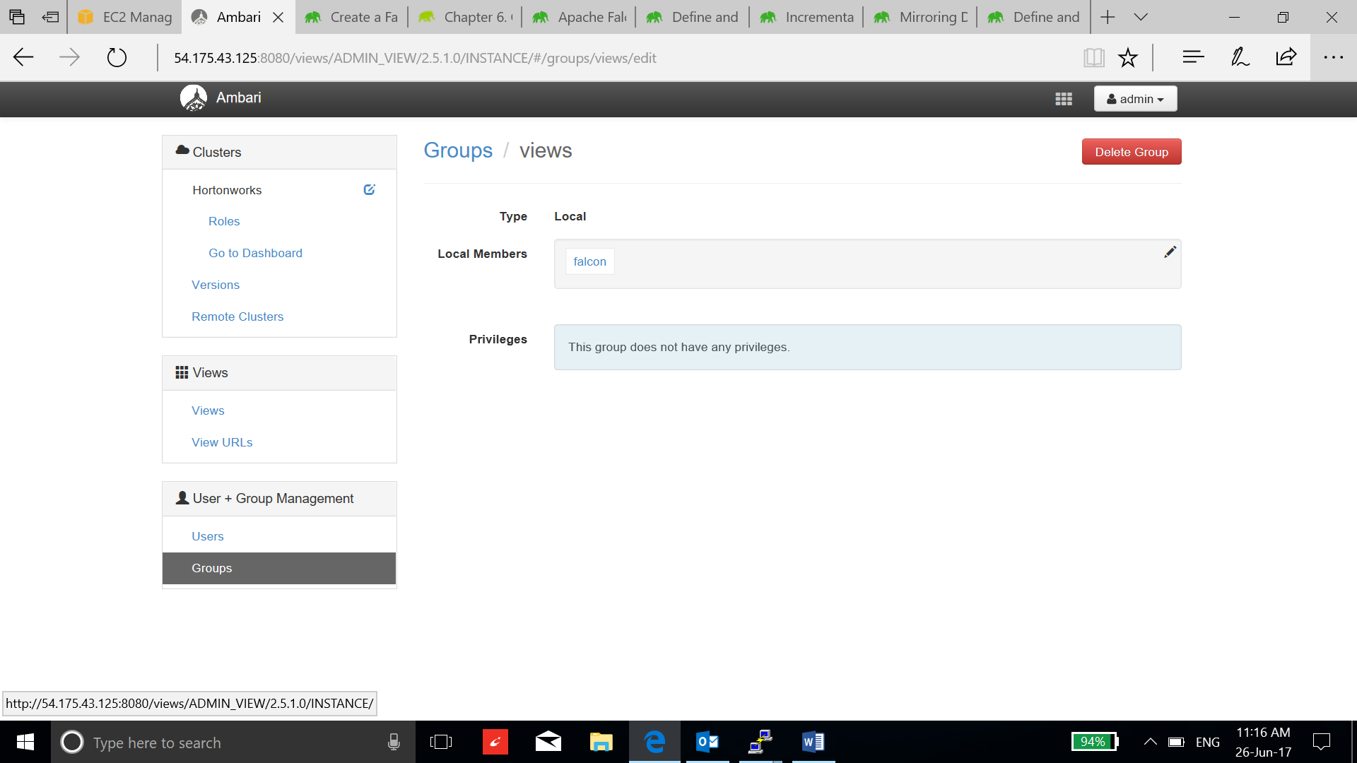

* Go to views and go to each view instance, add views group to the permission block.

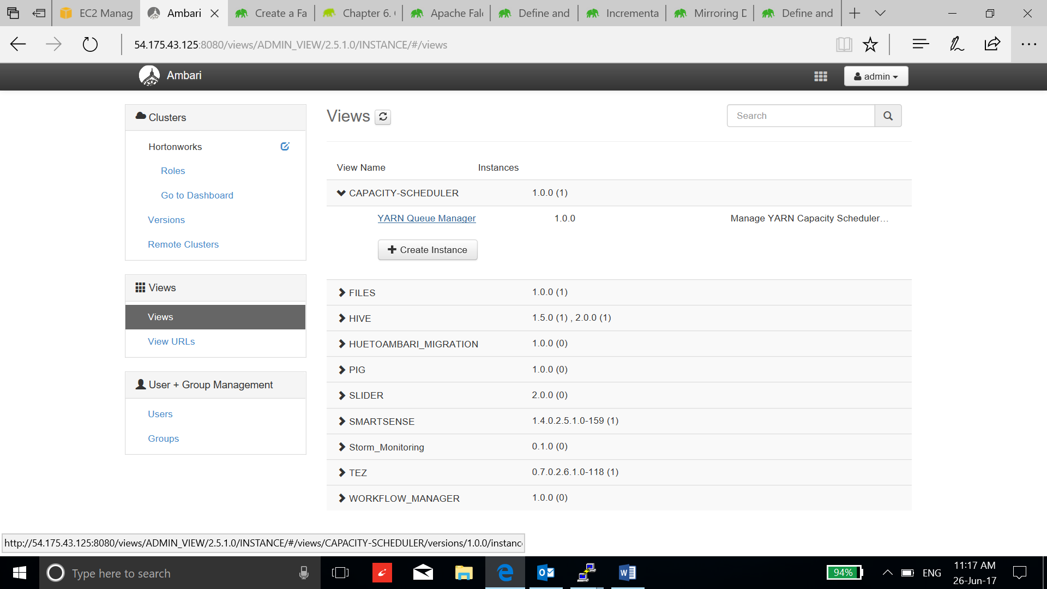

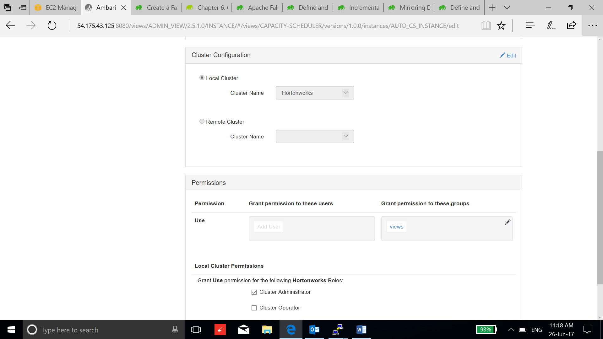

* Go to the users, select falcon and add views in the group bloack:

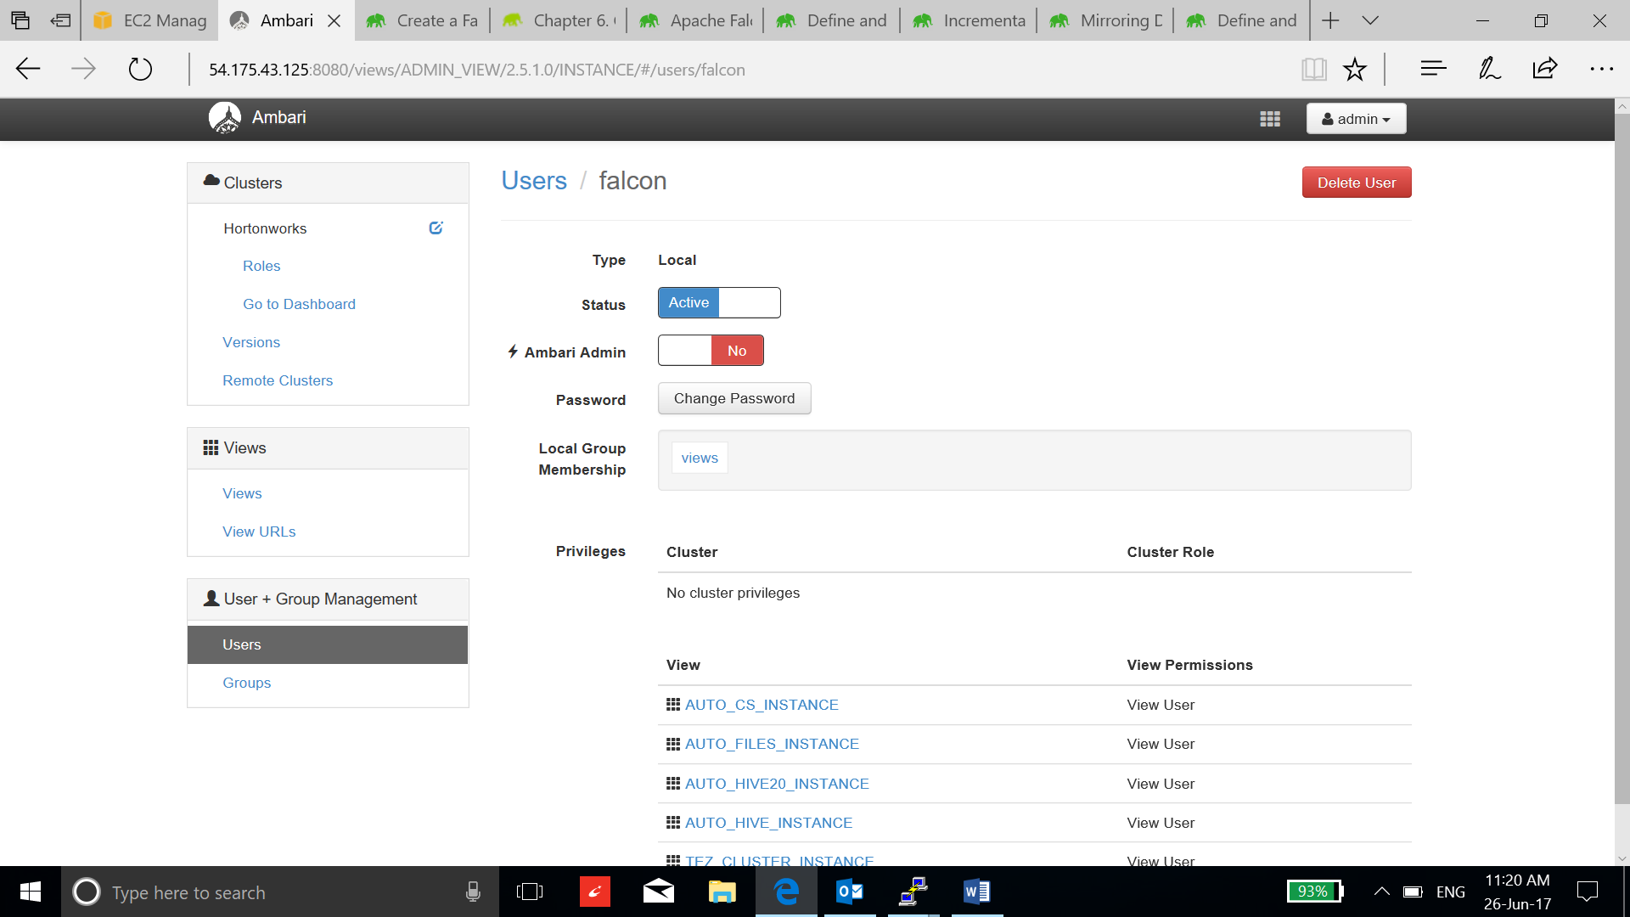

* Now log out as admin and sign in as Falcon user

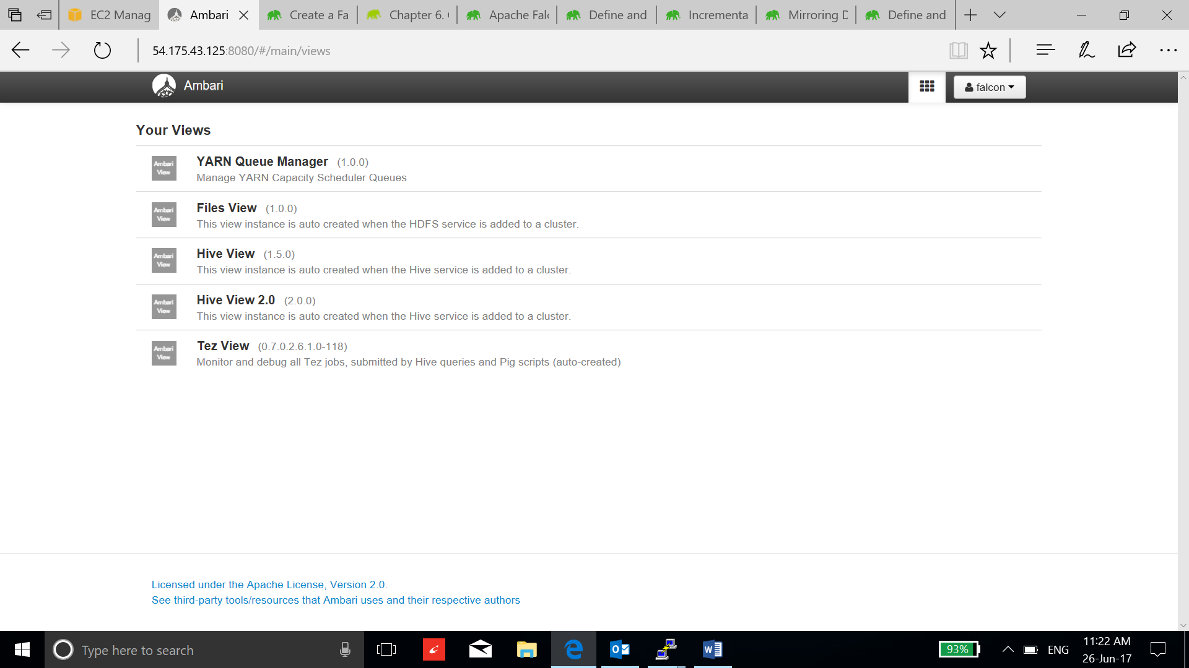

* Go to File view:

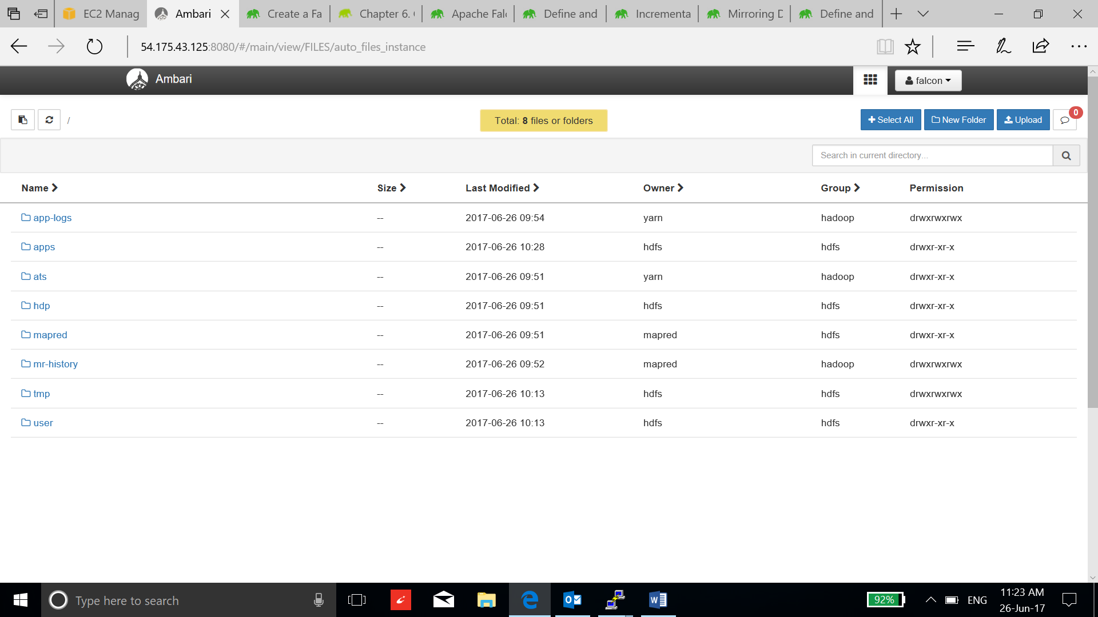

* We need to create the directories on HDFS representing the two clusters that we are going to define, namely primaryCluster and backupCluster. Navigate to /apps/falcon folder, click the New Folder button, an add new folder window appears and name the folder primaryCluster. Press enter or Add

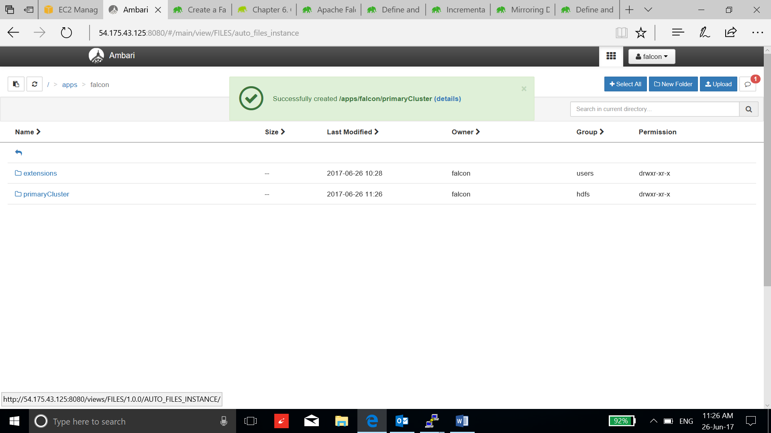

* Click on the row of primaryCluster directory and then click on Permissions button:

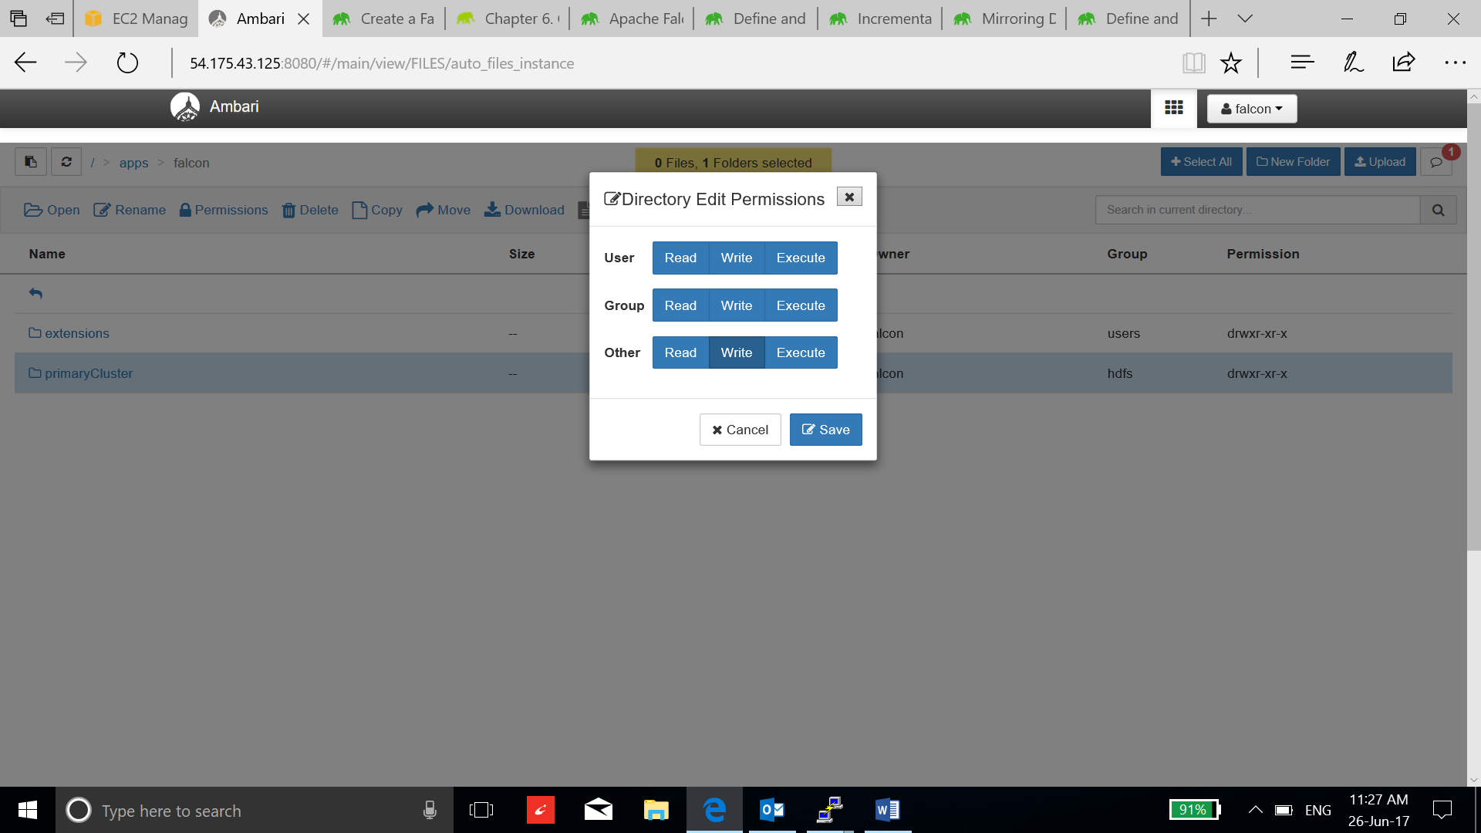

* Now go to the falcon web UI, use “falcon” as username:

ec2-54-85-141-12.compute-1.amazonaws.com:15000

* Now go to create and select cluster:

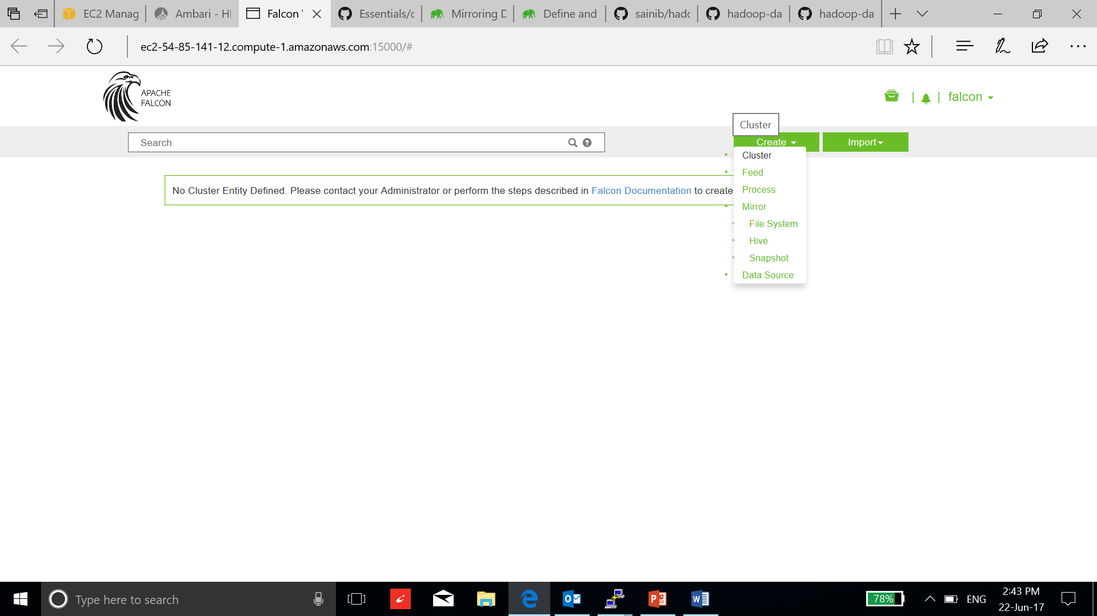

* Change the configuration according to the services addresses.

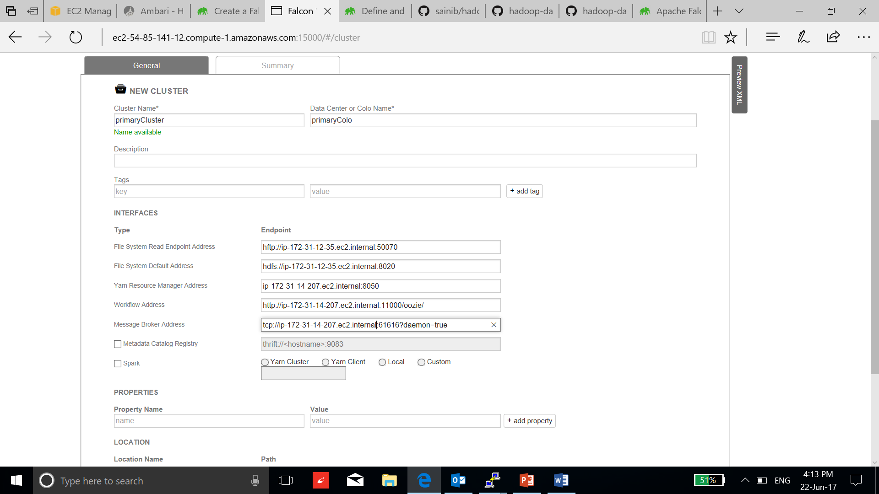

* Similarly, make a backupCluster.
* Create falcon directories in ambari-qa user:

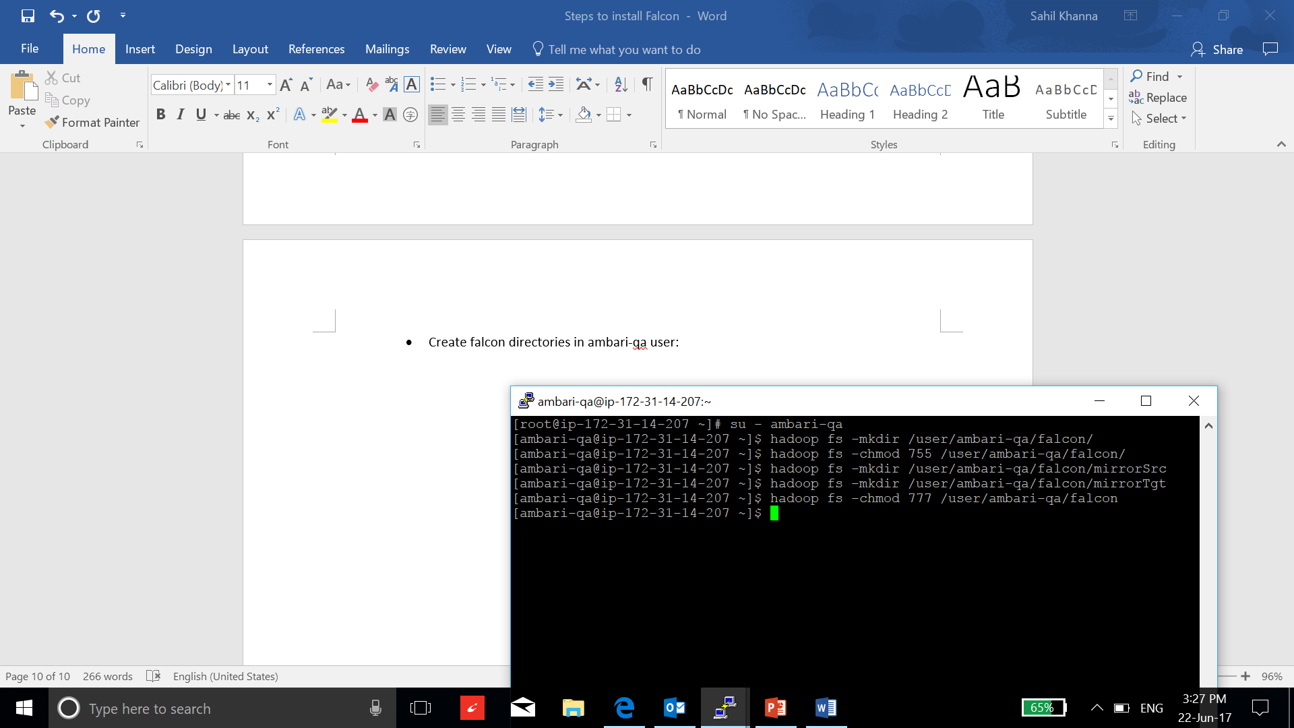

* Change the ambari-qa permission:

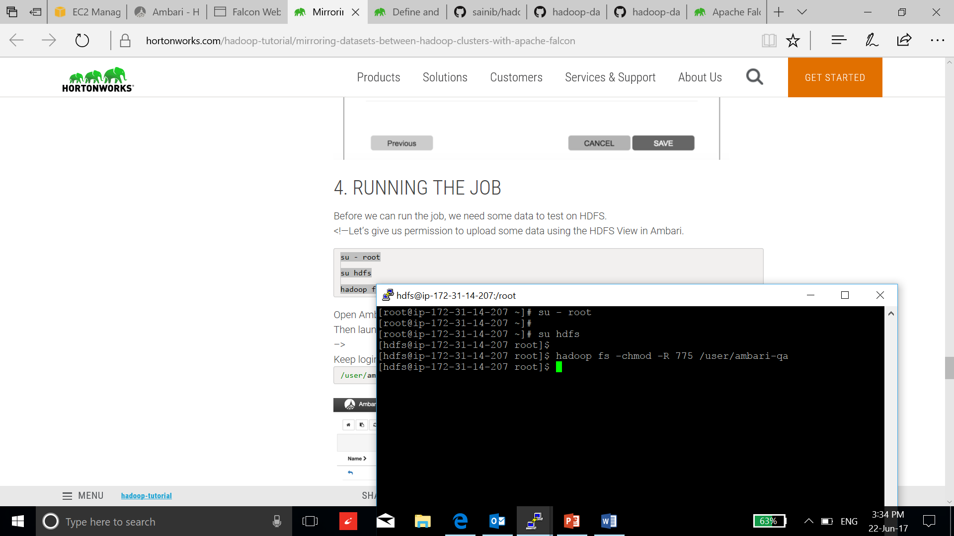

* Transfer a file in the mirrorSrc to test:

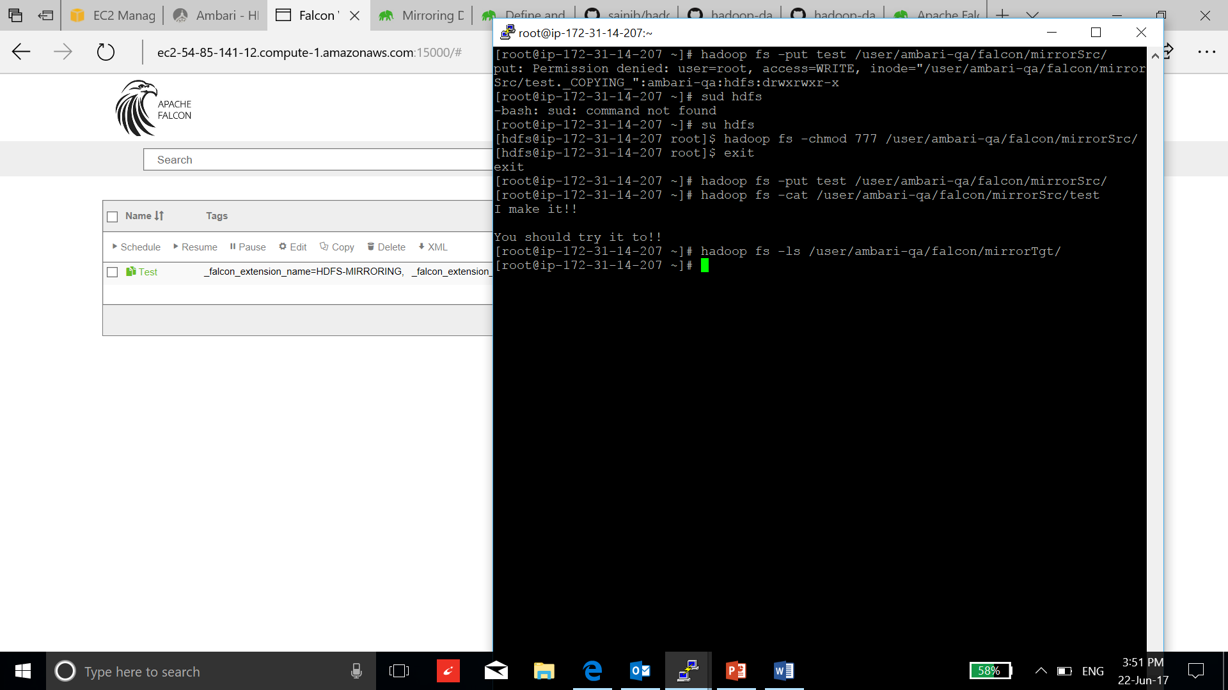

* Now, go to the create and select mirror to create mirror pipeline:

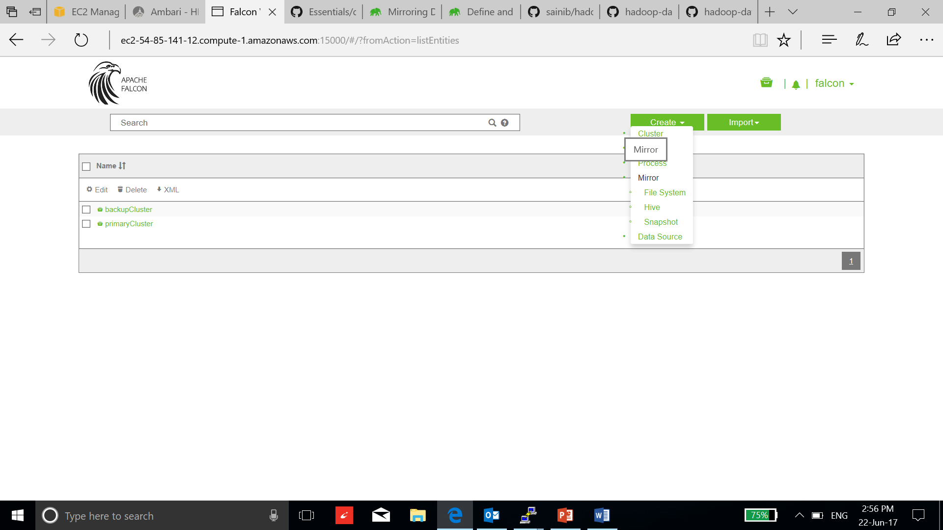

* Enter source and destination directories, click next and save:

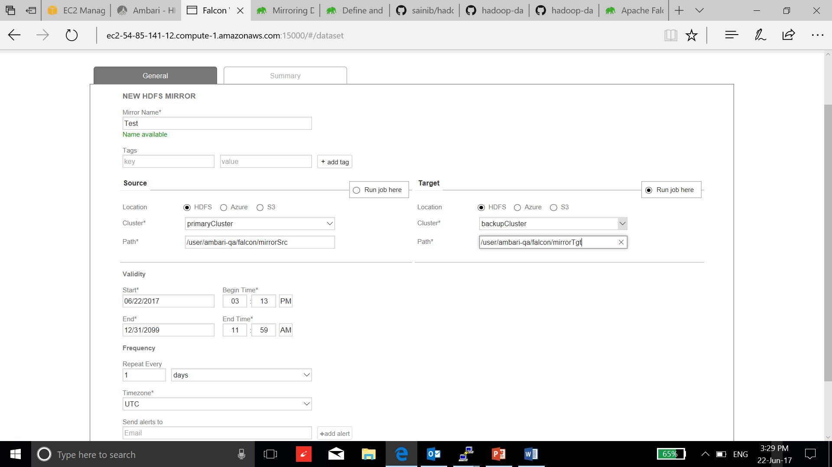

* Now select the mirror job and select schedule:

